7.1.9 Sensitization of students and employees of the Institution to the constitutional obligations: values, rights, duties and responsibilities of citizens

The institution strives to assist students in becoming better citizens in the future. To achieve this goal, the organization engages in a number of activities and projects aimed at instilling a feeling of constitutional obligations, including citizens' values, rights, duties, and responsibilities.
The college makes a concerted effort to educate its students and personnel about their constitutional responsibilities in the following areas:
Values and responsibilities:
The institution has always done a variety of direct and indirect actions to raise awareness of various values and rights. At the top of the institution building, different colored flags fly, sending a message of world fraternity and unity. With tremendous pomp and vigor, the institution commemorates Independence Day and Republic Day.
Fundamental Duties and Rights of Indian Citizens:
The institution has organized various academic and co-curricular activities for the propagation of the Fundamental Duties and Rights of the Indian citizens. The students of institution have actively participated in various programs like poster making competition, essay writing competition has been annually organized on the occasions of Hindi Divas Samaroh, Sadhbavana Divas, Ahinsa Divas,
Constitutional Obligations:
The college organizes and commemorates Constitution Day (Savidhan Diwas), contributing to the dissemination of constitutional values and ideas. In collaboration with Shrigonda Tehsil, the college commemorates Voter Registration Day and voter's Day to encourage new students to register.
Days celebrated
  - Sadbhavana diwas, (20th august)
  - Gandhi Jayanti (2nd October)
  - Teachers day (5th September)
  - Yoga day (21st June)
  - Independent day (15th August)
  - Republic day (26th January)
  - NSS day(24th September)
  - Women's day(8th March)
  - World environmental day(5th June)
  - Voters Day (25th January)

Vachan Prerana Din- 2021-22

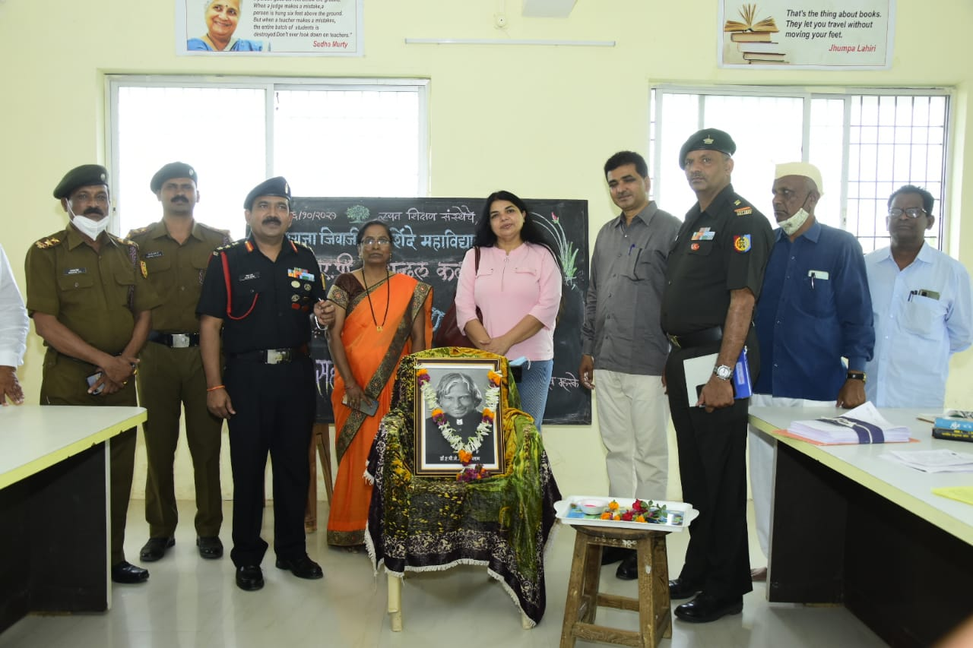

Vachan Prerna Din 2020-21

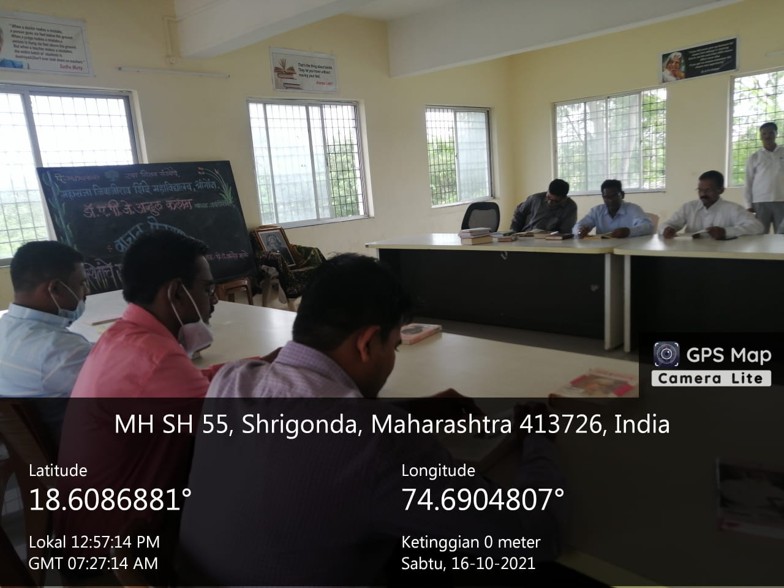

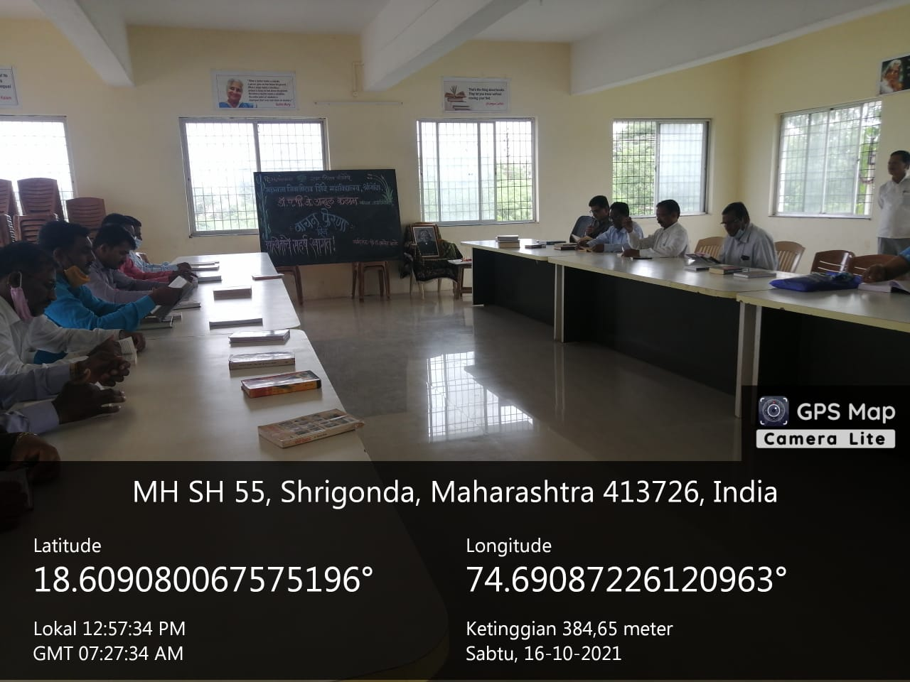

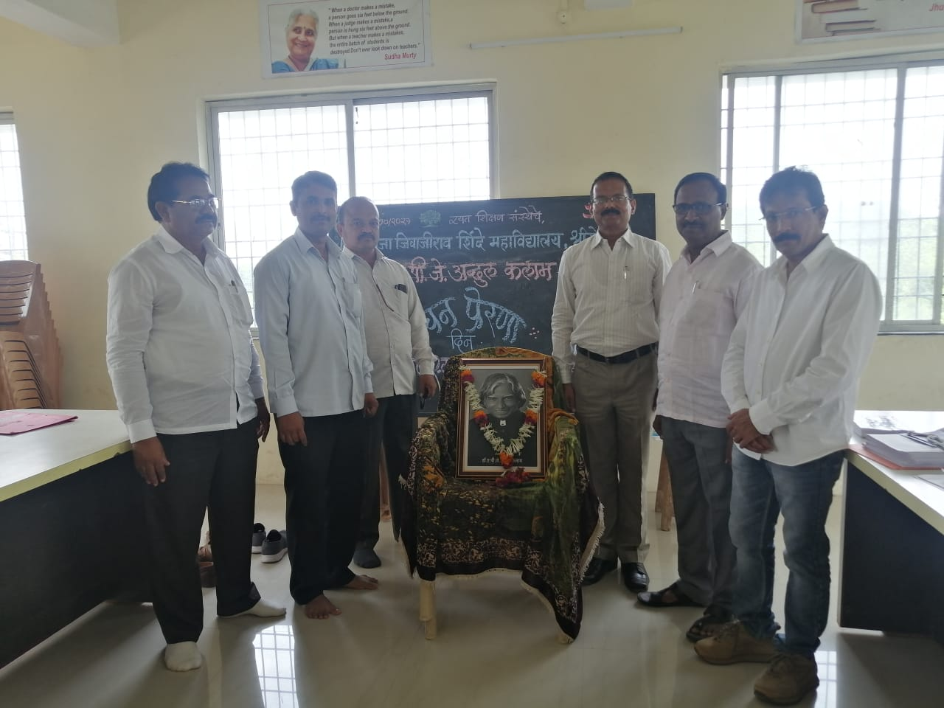

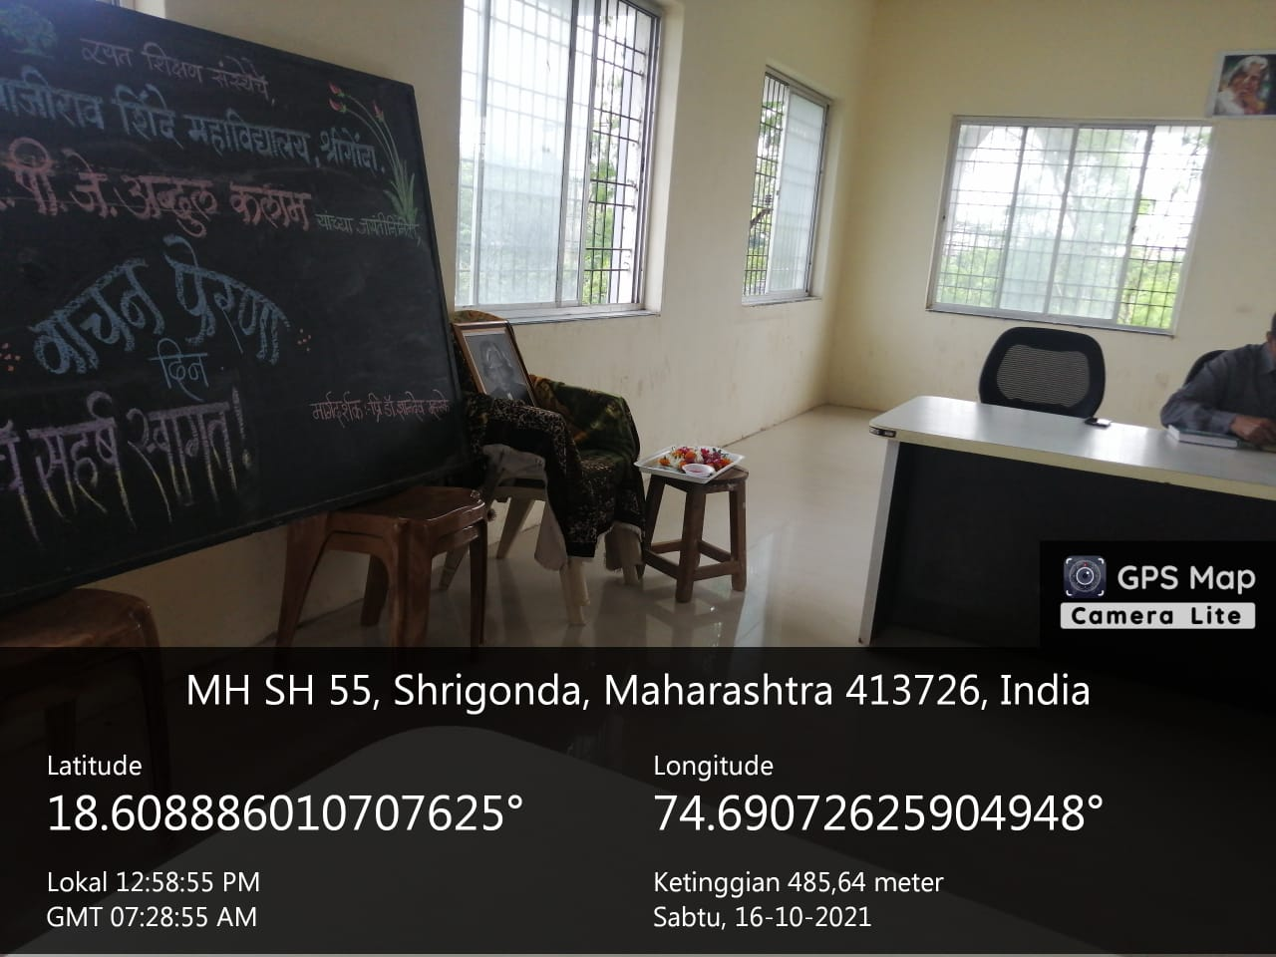

World Wildlife Week 02-08, October 202

Poster and Rangoli Presentation
